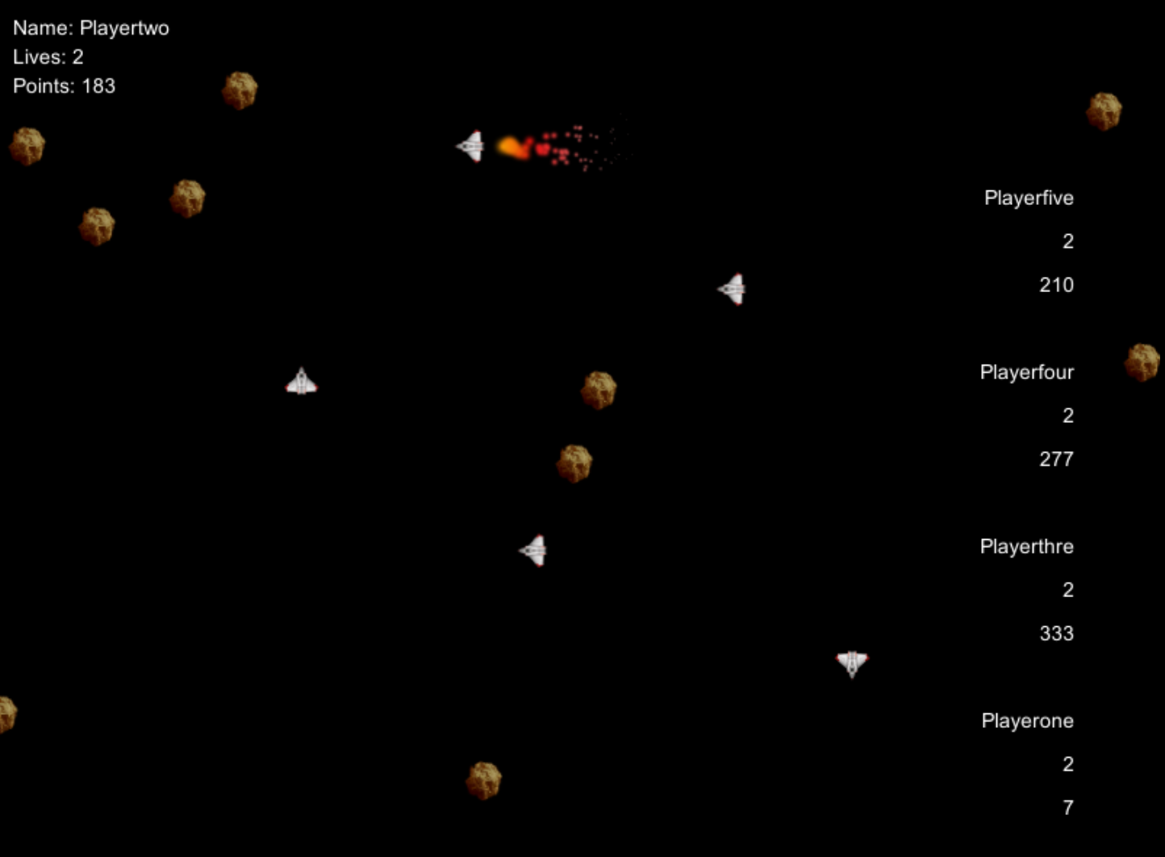
Anton Larsson
ante9311@gmail.com | +46707582993
Sernanders väg 5, 75261 Uppsala, Sweden
Curriculum Vitae

Personal information
• Name: Anton Larsson
• Date of birth: 19th November 1993
• Phone number: +46 70 758 29 93
• E-mail: ante9311@gmail.com

Education

Uppsala University 2014 – current
Bachelor of Computer Science, minor in mathematics.
Beyond merely making me a better programmer, this program has developed my understanding of everything around computers, making me able to write much more efficicent, maintainable and testable code.

Thorildsplans Gymnasium 2009 – 2012
Technical program with emphasis on networking and programming.
A great start for my programming experience. After having spent a few months teaching myself I received a great mentor who made sure I didn't pick up any bad habits while still enabling my growth as a programmer. Also studied courses from the Cisco program here, relatively close to a certificate.

Example Projects
Source code is available online.
There's also a couple of more interesting projects there.

Multiplayer Asteroids
- Complete report available online
- Highly concurrent back-end written in Go.
- .NET / C# and Unity front-end.
- Ultra scalable:
  - Up to 8 players in a single game.
  - Atleast 10+ games in progress at once,
even more with a more powerful server.

A multiplayer remake of the classic arcade game Asteroids.
The project I've learnt the most from in my 7 years as a programmer, as we had to figure out everything from how to structure a big project with a medium sized team, to how client-server communication works.

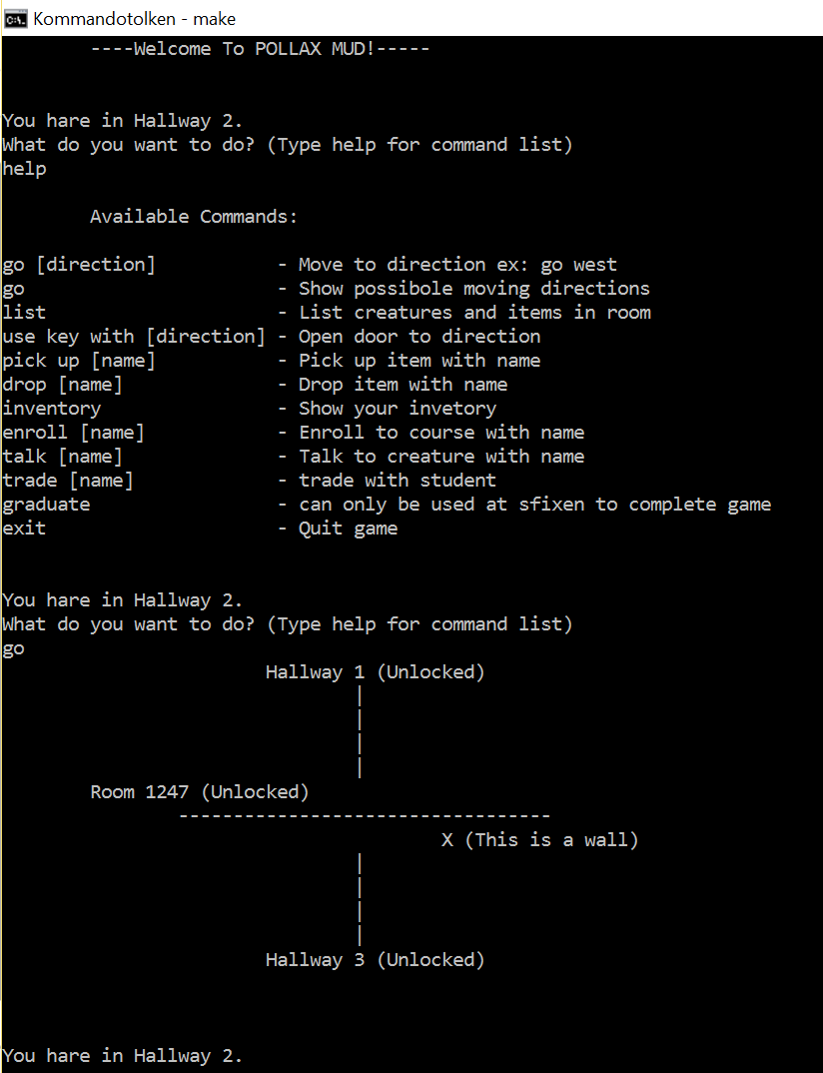

Pollax Mud game
- Written in java
- Complex hierachy and inheritance
- Excellent example of well documented and tested code
Simple role playing game set in the halls of Uppsala University, you are a student who can enroll in courses, take tests and eventually graduate!
We made this project to further explore inheritance and structures in slightly bigger java projects.

Work Experience
Consultant 2013 – 2014
Proffice – Stockholm, Sweden
Substitute for receptions and other facility management positions. Worked in many different environments and places, such as for Verizon and Philips, but also smaller companies such as Caverion.

Languages:
English – Fluent
Swedish – Fluent

